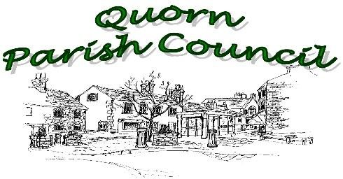
Minutes of the Planning Committee
Monday, 15th March 2021 – 9.00am Virtual Meeting
Present:
Cllr Josh Clayton | Cllr Carolyn Thornborow - Chair
Cllr Jane Hollingworth | Cllr Janice Slater
Cllr Andy McWilliam
Also in attendance: Deputy Parish Clerk, Eliza Hill

Item | Action
 | The Chair welcomed all to the meeting.
21/021 | Apologies
 | Apologies were received and accepted from Cllr Bob Parks.
21/022 | Declarations of interests
 | Cllrs Thornborow and Slater declared an interest as living in close proximity of an application on Station Road. Cllr Clayton declared an interest as a neighbour of the application on Cradock Drive and Cllr McWilliam declared an interest as living in close proximity of an application on Chaveney Drive.
21/023 | Minutes of the last meeting
The Chair invited members to suggest any corrections to the minutes.
With no matters raised, it was proposed that the minutes be agreed as a true account of the meeting.
RESOLVED: That the motion be carried.

21/024 | Clerk’s Report
 | The report was noted with no comments.
21/025 | Planning Application received since the last meeting
 | There had been eight applications received over the month but only two that members commented on:
 | 21/025a) P/21/0228/2- Proposed extensions and alterations to existing dwelling to create first floor accommodation and single storey extension to rear. Erection of new detached 2.5 storey dwelling, erection of double garage to front and proposed alterations to the access - 23 Buddon Lane, Quorn, (Revised scheme to P/20/0587/2).
Members felt that the narrow road is not suitable to cope with more traffic.

21/025b) P/21/0129/2- Extension to front of existing dwelling for porch and extensions to front and sides of outbuilding to create ancillary annexe. Erection of double garage to front of site - 1 Chaveney Road, Quorn.
Members felt that as this property is situated on a sharp bend and its driveway leads out directly to that bend, it would be dangerous to add more cars.

21/026 P/19/2139/2 – Miller Homes - Loughborough Road, Quorn

As amendments have been made to this application and with this application due to be discussed at the Charnwood Borough Planning Meeting on the 25th March 2021, this has been brought back to committee. As there are now proposals for a Quarry on Quorn Lodge Farm, members felt it was important to submit additional comments to those previously submitted in December.

Members felt that it was important to highlight that the proposed quarry will inevitably lead to additional heavy traffic in the area that has already been highlighted as a safety risk.
There is also concern that the quarry alongside the proposed development will contribute further to the flooding issues of Quorn and the surrounding areas and that water displaced from these sites will instead have a more detrimental effect on the village.

21/027 Street Naming and Numbering - Bull in the Hollow Farm

Members received the recommendations of the Heritage Warden.

Members agreed to support the suggestions of Plough Close/Road or Ploughlands as the first suggestion and to remove the Perry Herrick options due to the number of roads already using one or both of those names in such a small area.

21/028 | Community Actions
 | Quorn Community Interest Company – members received the Annual Report and Accounts. The report was noted with no comments.
21/029 | Community Resilience Plan
 | There was no report this month.
21/030 | Date of next meeting
 | Monday, 19th April 2021

