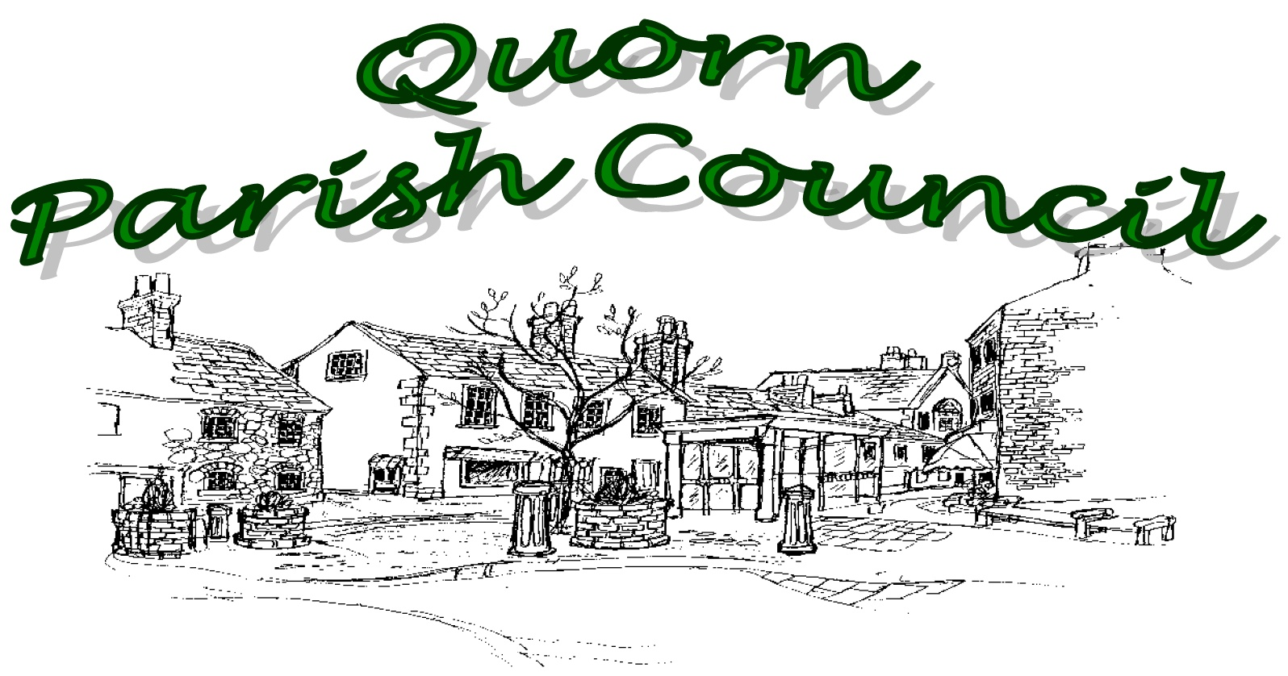

GRANTS POLICY AND GUIDANCE

GENERAL

Size of Grant
Quorn Parish Council makes small grants (typically hundreds or low thousands of pounds) but sets no formal limit to the size of grant.

Purpose of Grant
The Parish Council will fund only those organisations which bring benefit to the people of Quorn.
It is more likely to approve applications with the following characteristics:
- The project will benefit many people
- The project utilises volunteers from Quorn to deliver its activities
- Where the Parish Council is not the sole funder (other funds may be from the applicant organisation, third parties or earned income through the proposed activity)
It is less likely to approve applications:
- Whose purpose is the duty or role of other organisations
- Where the beneficiaries of the project are restricted, for example to the organisation’s members
The Parish Council will not fund:
- Expenditure incurred or committed to before the grant application is approved.

ELIGIBILITY
The Parish Council will fund organisations which:
- Are community, voluntary or charitable
The Parish Council will not fund individuals or organisations which:
- Are commercial or profit distributing
HOW TO APPLY
Save the Application Form from the Parish Council’s website. The form is in MS Word and should ideally be completed on the screen rather than printed and hand written. When complete print out and sign. Then either scan the signed form and e-mail to the Parish Clerk at parishclerk@quorndon.com or deliver by hand or by post to Quorn Parish Council, The Old School, School Lane, Quorn, Leicestershire LE12 8BL.
If you have any questions or want to discuss your application please telephone the Parish Clerk on 01509 458 278 during office hours 10.00am-12.00 noon Monday to Friday.

When completing the form do not use acronyms or technical terms which may not be commonly understood. Assume that the people who will read your application are unfamiliar with your organisation, its activities or its project.

Types of application
1) Annual Applicants and 2) Unit Applicants

Annual Applicants are organisations which have been recognised by the Parish Council as normally receiving an annual grant, although there is no guarantee that they will receive one.
These are:
- Carol Concert Organiser
- Band in the Park Organiser
- May Day Organiser
- Quorn in Bloom

All other applicants are Unit applicants

When to Apply
Annual Applicants should inform the Parish Clerk by the end of October what sum they anticipate applying for to cover the financial year commencing in the following April. Applications must reach the Parish Clerk by 10 January for consideration at the February Council meeting.
Unit Applicants must apply by the 10th of any month for consideration at the Council meeting in the following month.

Council Assessment Process
Applications submitted by the 10th of a month will be considered at the Council meeting in the following month, usually held on the first Tuesday of each month. Applicants will be informed of the outcome by the 10th of that month. The Council will give one of three responses: Approval,
Refusal or Deferment pending clarification or the submission of further information.

Attachments
The following list of attachments must be submitted with all applications. If your organisation is too new to have produced an annual report and accounts please explain this and send a copy of your current annual budget for your organisation.
- Copy of most recent bank statement
- Latest annual report and accounts
- Project Budget (that Grant is being applied for)
APPLICATION FORM DETAILS
CONTACT & BANK ACCOUNT (Confidential Information)
- Name of Organisation - This is the legal name of your organisation as it appears on your bank account and statements.
- Name of Contact Person - This is the name of the person completing the application and with whom QPC will liaise.
- Title of Contact Person - This is the title of the contact person within the organisation, eg Fund Raiser, Secretary, Volunteer.
- Correspondence Address - This is the postal address with post code, telephone number and e-mail address of the contact person.
- Name of Senior Person - This is the name, title within the applying organisation, full postal address, telephone and e-mail of the senior person who has authorised this grant application on behalf of the applying organisation, eg Chairman, Chief Executive, Director.

- Name of Bank Account - This is the legal name of the applying organisation as it appears on the bank account and bank statements. Include the account number and sort code. This is the account into which any grant will be paid.

- Bank Mandate - If your bank mandate does not require a minimum of two signatures on every payment (a basic anti-fraud measure) please explain why not.
- Bank Signatories - If any of your bank mandate signatories are connected to another signatory, please list all signatories and their relationships. “Connected” means two or more persons who are related by blood, marriage, civil partnership or co-habitation, or live on the same property or share a common purse, or are connected by friendship, or are in business together, or have a business relationship such as one being a tenant of another, one being a professional advisor to another, one employing another or both working for the same employer.

ORGANISATION

- Name of Organisation – This is the legal name of your organisation as it appears on your bank account. If you are also known by a working title or acronym, please give that also.
- Type of Organisation – State the legal structure of your organisation (eg limited company, community interest company, trust, unincorporated association, etc). State if you are a charity and
if so, state if you are registered with the Charity Commission together with your registration number.

- Date of Establishment – This is the year your organisation started being active and may pre-date the adoption of your present legal structure and governing document.
- Written Governing Document – Does your organisation have a written governing document? This is sometimes known as a constitution, memorandum and articles of association, rules or similar name. Unless requested there is no need to send a copy of this.

- Services, Facilities and Activities – Describe what your organisation does, its number of staff and volunteers, and its annual financial turnover. Specifically include any activities in Quorn.
- Who Benefits - Describe your organisation’s beneficiaries and how they benefit. Specifically include any in the parish of Quorn.
- Public Liability Insurance – All organisations should have public liability insurance. If your organisation does not have such insurance please explain why not.
- All Grants Received – List all grants received by your organisation from Quorn Parish Council in the last three years with the amount of money and a very brief description of the purpose.

PROJECT

- Name of Project – Use a name which describes what you will do (for which the grant is proposed)

- Date(s) of Project – Give the start date and end date of your project, or the event date

- Description of Project – Describe your project in detail. Who will do what and when and why. You may attach other documents to aid your explanation but bear in mind the limited time of Parish Clerks and Councillors to absorb information.

- Who will Benefit - How many people will benefit from this project and how many of them are residents of Quorn? Please describe what categories of people will benefit if the benefit is restricted to or targeted at specific groups. Please describe how the beneficiaries will benefit.

- Project Cost – Show the gross cost of the whole project from your Project Budget.

- Grant Application Value – Show a single figure in pounds sterling. Do not ask for a range of funding but be specific.
- Other Funding – How much other funding for this project will you need? Where is it to come from and have you already got or been promised any of it?
- Parish Council Resources – If you are planning to use the Village Hall or Old School for an event you will have to book this and pay for it through the standard system. If you are going to rely on assistance from Council staff (for example the assistance from the groundsman for events in Stafford Orchard) has this been discussed with the Parish Clerk?

GRANT CONDITIONS

By submitting a grant application to Quorn Parish Council (QPC) the organisation named in the Application (you or your) agrees, if awarded a grant, to the following:
- To hold the grant on trust for QPC and use it only for the Project described in the Grant Application, or otherwise agreed by QPC, and only for expenditure agreed after the date of the grant award.
- Keep accurate and comprehensive records about the Project during the Project and for at least three years after the end of the Project.
- Provide QPC promptly with any information and reports requested about the project and its impact, during and after the end of the Project.
- Allow QPC or its agents reasonable access to your premises and systems to inspect Project and Grant records.
- Acknowledge QPC’s funding appropriately in published material and press releases.
- Promptly return any part of the Grant that is not used for your Project.
- You acknowledge that QPC is entitled to require you to repay all or any of the grant in any of the following situations and that you will promptly advise QPC if any of these situations has occurred or is likely to occur:
a You use the grant in any way other than approved by QPC or fail to comply with any of these Conditions.
b You fail to make good progress with your Project or are unlikely in our view to complete the Project or achieve the objectives agreed with QPC.
c You have other funding withdrawn from the Project or receive duplicate funding for the same Project costs as funded by QPC’s grant.
d You provide QPC with false or misleading information on application or after award of the Grant, act dishonestly or are under investigation by QPC, the Police or other regulator, or if QPC considers for any reason that public funds are at risk or you do anything to bring QPC into disrepute.
e You enter into or are likely to enter into administration, receivership or dissolution.
- QPC will not increase the grant if you spend more than the agreed budget.
- QPC has no liability for any costs or consequences incurred by you or third parties that arise directly or indirectly from the Project.

END-OF-GRANT REPORT

Within one month of completing your project you will send the Parish Council a short report on your project. Within the report please include the following information:

Name of Organisation Name of Project
Name and contact details of the person submitting the End-of-Grant Report Date of End-of-Grant Report
A description of what was accomplished, comparing this to what was intended on the grant application

A description of how many beneficiaries benefitted, how many of those were residents of Quorn and in what way they benefitted, comparing this to what was intended on the grant application

A financial report of your project, comparing this to the grant application budget and explaining any significant changes

This information is intended to assist the Parish Council in improving their Grant Procedures

GRANTS - APPLICATION FORM
(Confidential Information - Please type application using Word)

Papers for Parish Council meetings, including this grant application are in the public domain and are published shortly before the meeting. But this front page containing personal information will be detached so that it is not published and does not go to the meeting.
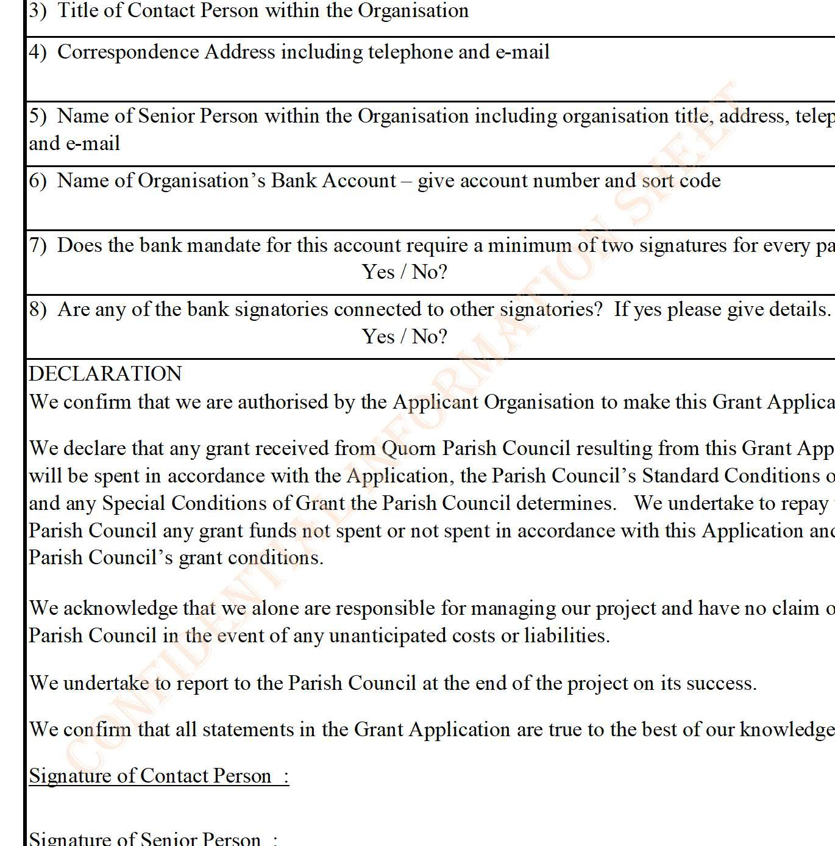
Applicants are strongly advised to carefully read the Guidance before applying.
CONTACTS & BANK ACCOUNT
  - Name of Organisation

  - Name of Contact Person
3) Title of Contact Person within the Organisation
4) Correspondence Address including telephone and e-mail

5) Name of Senior Person within the Organisation including organisation title, address, telep and e-mail
6) Name of Organisation’s Bank Account – give account number and sort code

7) Does the bank mandate for this account require a minimum of two signatures for every pa
Yes / No?
8) Are any of the bank signatories connected to other signatories? If yes please give details.
Yes / No?
DECLARATION
We confirm that we are authorised by the Applicant Organisation to make this Grant Applica

We declare that any grant received from Quorn Parish Council resulting from this Grant App will be spent in accordance with the Application, the Parish Council’s Standard Conditions o and any Special Conditions of Grant the Parish Council determines. We undertake to repay Parish Council any grant funds not spent or not spent in accordance with this Application and Parish Council’s grant conditions.

We acknowledge that we alone are responsible for managing our project and have no claim o Parish Council in the event of any unanticipated costs or liabilities.
We undertake to report to the Parish Council at the end of the project on its success.

We confirm that all statements in the Grant Application are true to the best of our knowledge Signature of Contact Person :
Signature of Senior Person :

hone

yment?

tion.

lication f Grant to the the

n the

.

D ate :

GRANT APPLICATION TO QUORN PARISH COUNCIL | 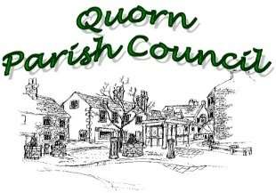
(Sheet to be Published)
ORGANISATION
1) Name of Organisation
2) Type of Organisation – If applicable give charity/company registration numbers
3) Date of Establishment:
4) Written Governing Document:
Yes / No
5 What services, facilities and activities does your organisation provide?
6) Who benefits from these services, facilities and activities with particular reference to the people of Quorn.
7) Does your organisation have a Public Liability Insurance Policy?
Yes / No?
8) List all grants received from Quorn Parish Council in the last three years.

PROJECT
(Sheet to be Published) | 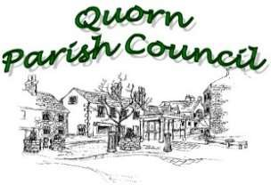
1) Name of Project
2) Date of Project - When will this Project start and end or take place?
3) Description of Project
4) Who will Benefit
5) How much money will this Project cost?
6) How much money is this Grant Application for?
7) Where will the difference between Project Cost and Grant Application come from?
8) What Parish Council facilities such as buildings or open space will the Organisation want to make use of? And what assistance from Council staff (if any) will the Project need?

This page is for Parish Office use only
GRANT APPLICATION – REPORT BY PARISH CLERK

QPC Schedule Record No_
1) Name of Organisation
2) Date Application Received
3) Has the Declaration been signed by two persons?
4) Is the bank account in the name of the organisation, does it require two signatures on all payments and are all the signatories unconnected?
5) Have all questions been fully answered?
6) Have all attachments been received and reviewed?
7) Any issues needing clarification? - details
8) Have identified issues been raised with applicant & been clarified by the applicant - any details add in
9) Has the applicant submitted End-of-Grant Reports for any previous grants from the Parish Council?

